

**Homestead High School Parent Club Scoop**

Good afternoon! You are receiving our first newsletter because during registration you indicated that your family would like to receive emails about Parent Club events, educational meetings, volunteer opportunities etc. Thank you for being a part of Homestead High School Parent Club. We look forward to seeing you at one of our meetings or events!

To volunteer, just visit the newly created Parent Club website below or click the link below for Sign-Up Genius Link:

<http://www.signupgenius.com/go/10C0F49A9AB22A75-welcome>

Please visit our website to volunteer, donate or find out about our events and meetings @ [www.hhsparentclubfw.com](http://www.hhsparentclubfw.com)

**Parent Club Meetings- First Meeting September 10th @11am**

Our meetings are held on the second Thursday of each month at 11 am in the main building’s community room (enter thru door #1). These meetings are educational and Mr. Ginder and/or other admin staff attend each meeting to answer any questions and discuss topics of interest.

At our first meeting Assistant Principal Susan Summers will be in attendance to discuss the new Canvas software that replaced My Big Campus. Bring your questions and concerns! Also she will speak briefly about the new School Board decision about the topic of “weighted grades”. She can also address any other questions or concerns your family might have.

**Registration Day**

Parent Club and Homestead staff wish to thank all the volunteers who stepped up to work on registration day. Without all of you we couldn’t have pulled off the day. It ran so smoothly. We appreciated your assistance in making that happen.

**HHS Teacher Workroom Volunteer**

Every year we assist the HHS staff by volunteering to work in the main building teacher workroom with various copying and laminating requests. Each school day we endeavor to have a parent in the workroom for one - three hours in the **morning** (depending on the requests for that day). You can volunteer on a regular basis, or be on a sub list for last minute help. Training is provided.

If you are interested, then go to the [sign-up genius link](http://www.signupgenius.com/go/10c0f4aaeaa2ea57-hhsworkroom1) for more specific information, or contact [Liz Auger](mailto:augerfamily@comcast.net?subject=HHS%20Workroom%202015-16).

If you like working on your own with a little direction and enjoy copying/organizing…then we would love to have you help out. The staff really appreciate the time it saves them and we help give back to the teachers.

Click [here](http://www.signupgenius.com/go/10c0f4aaeaa2ea57-hhsworkroom1) for sign-up genius link.

<http://www.signupgenius.com/go/10c0f4aaeaa2ea57-hhsworkroom1>

SAT/ACT for Practice Exams

Below you will find information about our Parent Club sponsored SAT/ACT for practice exams. These exams for practice are held 2 times a year. Deadline for registration the first session is Sept 25th. Please consider signing your student up for a SAT/ACT for practice exam. If you have questions re: SAT/ACT for Practice please email @

[hhspracticeexams@gmail.com](mailto:hhspracticeexams@gmail.com)

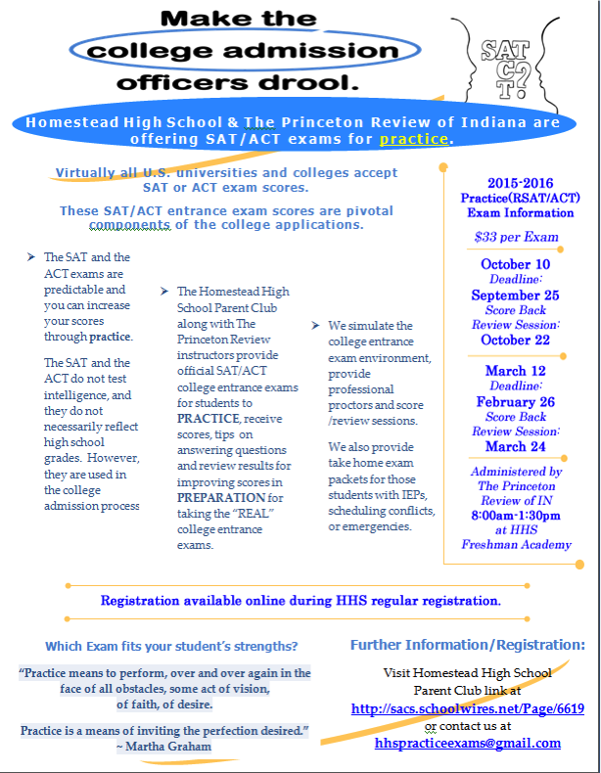



Coming events…

* Our first Staff Appreciation event will be held in October. Look for details in next newsletter. The staff are always so appreciative of your donations of food. We know your time is precious and we listened to your suggestions. This year we have added a “Donation” button specifically for Staff Appreciation on our new web site @ [www.hhsparentclubfw.com](http://www.hhsparentclubfw.com) Please visit website listed and click on “Giving/Donations” tab to make a donation. You may donate any amount and the committee will use that donation to purchase items needed for the events.

* Another event that is coming up is Staff Curriculum Grants. Each year, we use some of the money we get from dues and our Parent Club sponsored SAT/ACT for practice exams for Staff Curriculum Grants. These grants are issued before Christmas break. We typically spend $7-12,000 on our grants. Multiple staff receive grants varying from $200-2000. Again, you may contribute directly to the Staff Curriculum Grants by visiting our web site and clicking on the “Giving/Donations” tab @ [www.hhsparentclubfw.com](http://www.hhsparentclubfw.com)

Questions, comments, concerns etc. please email us @ [hhsparentclubfw@gmail.com](mailto:hhsparentclubfw@gmail.com)